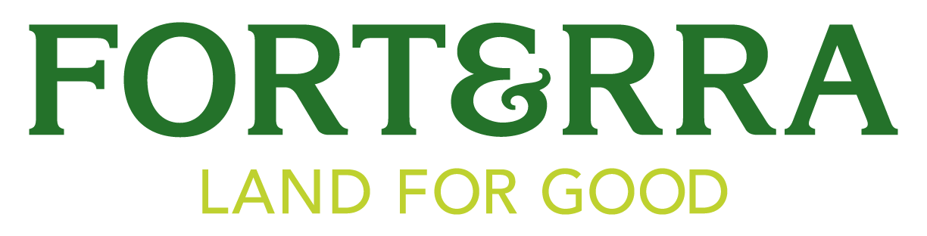

Community Restoration Grants Program Application

Forterra’s Community Restoration Grants (CRG) aim to promote community self-determination and maximize social and environmental equity. The program, supported by the One Square Fund, will provide grants up to $25,000 in urban and suburban communities. Projects that support improvement of environmental and community health through urban park restoration, tree canopy improvement or other environmental objectives are eligible for funding. Preference will be given to projects that involve community support and coordination, include youth involvement, directly support BIPOC or low-income communities and demonstrate project sustainability after the grant period.

Grant applications are due by midnight on September 30th. There will be two additional funding rounds open on November 1, 2023, and March 1, 2024. Applicants that have been funded in prior rounds are not eligible for additional funding. Previously unfunded applicants are encouraged to apply for each round.

Grant Guidelines
Funding
Target proposals range from $10,000 - $25,000, but in some circumstances, we will consider projects under $10,000. The maximum amount that can be applied for is $25,000. Grants may be partially or fully funded.

Grant funds can be used for staff time, stipends, materials, plants, and other project expenses. Up to 15% of funds can be used for administrative time.

Sites
Grant-funded work cannot be used on private property inaccessible to the public. Grant funds may be used on:
- Public land or land open to public access
- Land being used for public education
- Tribal lands accessible by Tribal members (general public restrictions are allowable)

If you have any questions about whether your site is considered publicly accessible, please reach out to the Program Coordinator, at restoration@forterra.org.

Priority will be given to projects:
- Involving community support/coordination
- Including youth involvement
- Directly supporting underserved communities
- Demonstrating project sustainability after the grant period

Applicant Eligibility
Applicants must be a 501(c)3 organization, fiscally sponsored by a 501(c)3, or a Tribal entity within Washington state. Individuals or for-profit entities are not eligible to be a lead applicant. Individuals or for-profit entities must partner with or be fiscally sponsored by a 501(c)3 or Tribal entity. While government agencies aren’t eligible, they are encouraged to partner with recipients.

How to Complete the Application
Please download and fill out the application form in its entirety. You can submit the application as a word document or PDF to restoration@forterra.org. Please paste maps and photos, as applicable, directly into the appendices section of the application and label as appropriate. If you are not the landowner, please provide a letter of support from the landowner confirming their support of the project by separately attaching the letter in the email. You are welcome to use the template letter of support available on the Community Restoration Grants website.

If you have any questions, contact the Program Coordinator at restoration@forterra.org.

Please submit the following application to the following address by September 30, 2023 by midnight:
restoration@forterra.org

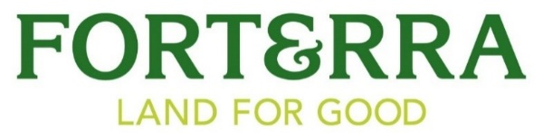

Community Restoration Grants Program Application

Date submitted:

Project Title:

Organization Name:

Organization EIN (if applicable):

Project Location:

Applicant:
Name
Address
Phone
Email

- Amount of Funding Requested:

- Project Summary and Objectives: Provide a brief description of proposed project. (250 words maximum)

- Project Partners and/or Youth: In one paragraph, describe your partners in the project. If youth will be involved, please detail how they will be recruited. (100 words maximum)

- Project Location: In one paragraph, describe the location of the project. (50 words maximum)

- Concerning your site location(s):
  - Score of project location(s) according to the Washington Environmental Heath Disparities Map (map link: https://fortress.wa.gov/doh/wtn/WTNIBL): _____________

  - Score of project location according to the Tree Equity Score Map (map link: https://treeequityscore.org/map/#6.11/47.342/-120.412): _____________

  - Site accessibility: Is your site accessible to the public? Yes☐ No ☐

- Long-term management strategy for this project (if applicable): Provide a brief statement of how the project will be maintained after the grant period. (100 words maximum)

- Budget: Detail how your budget will be spent:
  - Staffing:
  - Stipends:
  - Materials and Supplies:
  - Travel:
  - Other (detail):

- Native Plants: Do your grant-funded restoration activities or related programming use only native plants (as defined in the Request for Proposals)? Yes☐ No ☐

Appendix A
Project Map(s): Provide a map that will show the site and the location of the work being done.

Appendix B (if applicable)
Site Photos: Provide 3-5 photos of the site and/or your program.

Appendix C (if applicable)
Landowner Permission: If you are not the landowner, attach a letter of support for your proposal from the landowner when you send in the application.

-------------
End of application.

If your grant application is denied, would you like to receive feedback on why it was denied in case you apply for the next grant round?
Yes☐ No ☐

