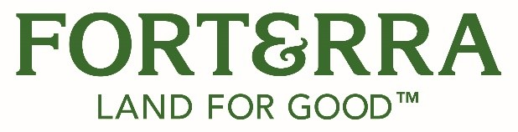

**Community Restoration Grants Program Application**

Forterra’s **Community Restoration Grants (CRG)** aim to promote community self-determination and maximize social and environmental equity. The program launched with initial support from the One Square Fund and will provide grants of up to $25,000 in urban and suburban communities. Projects that support improvement of environmental and community health through urban park restoration, tree canopy improvement, or other environmental objectives are eligible for funding. Preference will be given to projects that benefit the community, include youth involvement, and directly support BIPOC or low-income communities.

Grant applications are due by midnight on April 15, 2025. Applicants can only receive a funding award once per calendar year. Previously unfunded applicants are encouraged to apply again.

**Grant Guidelines**

Funding

Target proposals range from $10,000 - $25,000, but in some circumstances, we will consider projects under $10,000. The maximum amount that can be applied for and awarded is $25,000. Grants may be partially or fully funded.

Grant funds can be used for staff time, stipends, materials, plants, and other project expenses. Up to 15% of funds can be used for administrative time.

Sites

Grant-funded work cannot be used on private property inaccessible to the public. Grant funds may be used on:

* Public land or land open to public access
* Land being used for public education
* Tribal lands accessible by Tribal members (general public restrictions are allowable)

If you have any questions about whether your site is considered publicly accessible, please reach out to the Program Manager, at [restoration@forterra.org](mailto:restoration@forterra.org).

Projects should:

* Directly align with the Community Restoration Grant goals outlined on the [website](https://forterra.org/our-work/programs/community-restoration-grants/) (Graded as a score out of 7)
* Include hands-on restoration work (True/False)
* Demonstrate project feasibility during the grant period (True/False)
* Demonstrate project sustainability after the grant period (True/False)
* Demonstrate that there is clear community support (True/False)
* Primarily use native plants (at least 75%). If you are unsure if a plant counts as native, you can contact [restoration@forterra.org](mailto:restoration@forterra.org). (True/False)

Priority will be given to projects that also:

* Provide environmental benefits to the community (35%)
* Demonstrate that there is clear community impact (25%)
* Benefit or support youth understanding and experience in restoration work (25%)
* Support underserved communities (15%)

Applicant Eligibility

Applicants must be a 501(c)3 organization, fiscally sponsored by a 501(c)3, or a Tribal entity within Washington state. Individuals or for-profit entities are not eligible to be a lead applicant. Individuals or for-profit entities must partner with or be fiscally sponsored by a 501(c)3 or Tribal entity. While government and quasi-government agencies aren’t eligible, they are encouraged to partner with those that are eligible.

**How to Complete the Application**

Please download and fill out the application form in its entirety. You can submit the application as a word document or PDF to [restoration@forterra.org](mailto:restoration@forterra.org). Please paste maps and photos, as applicable, directly into the appendices section of the application and label as appropriate. If you are not the landowner, please provide a letter of support from the landowner confirming their support of the project by separately attaching the letter in the email. Applications that do not have the support of the landowner will not be reviewed. You are welcome to use the template letter of support available on the [Community Restoration Grants website](https://forterra.org/our-work/programs/community-restoration-grants/).

If you have any questions, contact the Program Manager at [restoration@forterra.org](mailto:restoration@forterra.org).

**Please submit the following application to the following address by April 15, 2025, by midnight:** [restoration@forterra.org](mailto:restoration@forterra.org)

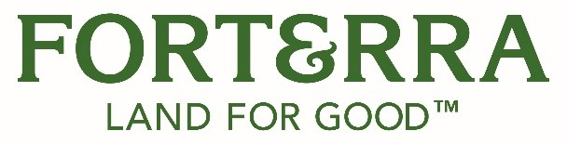

**Community Restoration Grants Program Application**

**Date submitted:**

**Project Title:**

**Organization Name:**

**Organization or sponsoring organization EIN:**

**Project Location:**

**Applicant:**

|  |  |
| --- | --- |
| Name and Title (if applicable) |  |
| Address |  |
| Phone |  |
| Email |  |

1. **Amount of Funding Requested:**

1. **Project Summary and Objectives:** Provide a brief description of the proposed project. The description should briefly explain public access to the site, the ecological benefits of the project, and how the community will benefit from this project. Priority will be given to projects that demonstrate large community and environmental impact, community support or coordination, meaningful youth involvement, and/or support for underserved communities (half-page minimum, 2 pages maximum)

1. **Project Partners and/or Youth:** Describe your partners in the project. If youth will be involved, please detail how they will participate in the project. (half-page minimum, 1 page maximum)
   1. All project partners for this project have been consulted and confirmed their involvement. Yes☐ No ☐
2. **Project Location:** In one paragraph, describe the location of the project. (quarter-page minimum 1 page maximum)
3. **Concerning your site location(s):**
   1. **Score of project location(s) according to the Washington Environmental Heath Disparities Map** (map link: <https://fortress.wa.gov/doh/wtn/WTNIBL>)**:** _____________

* 1. **Score of project location according to the Tree Equity Score Map** (map link: <https://treeequityscore.org/map/#6.11/47.342/-120.412>)**:** _____________
  2. **Site accessibility:** Is your site accessible to the public? Yes☐ No ☐

1. **Long-term management strategy for this project** (if applicable): Provide a brief statement of how the project will be maintained after the grant period. (half-page maximum)
2. **Budget:** Detail how your budget will be spent:
   1. **Staffing:**
   2. **Stipends:**
   3. **Materials and Supplies:**
   4. **Travel:**
   5. **Other (detail):**

1. **Native Plants: What percentage of plants** from your grant-funded restoration activities or related programming are native as defined in the Request for Proposals? _________

**Appendix A**

**Project Map(s):** Provide a map or map link that will show the site and the location of the work being done.

**Appendix B**

**Site Photos:** Provide 3-5 photos of the site and/or your program.

**Appendix C** (if applicable)

**Landowner Permission:** If you are not the landowner, attach a letter of support for your proposal from the landowner when you send in the application.

*End of application.*

***If your grant application is denied, would you like to receive feedback on why it was denied in case you apply for the next grant round?***

Yes☐ No ☐